**WRITING AN EMAIL**

* Email layout;
* The different steps to be taken when writing emails.

**1/ Read the following email and label the different parts.**

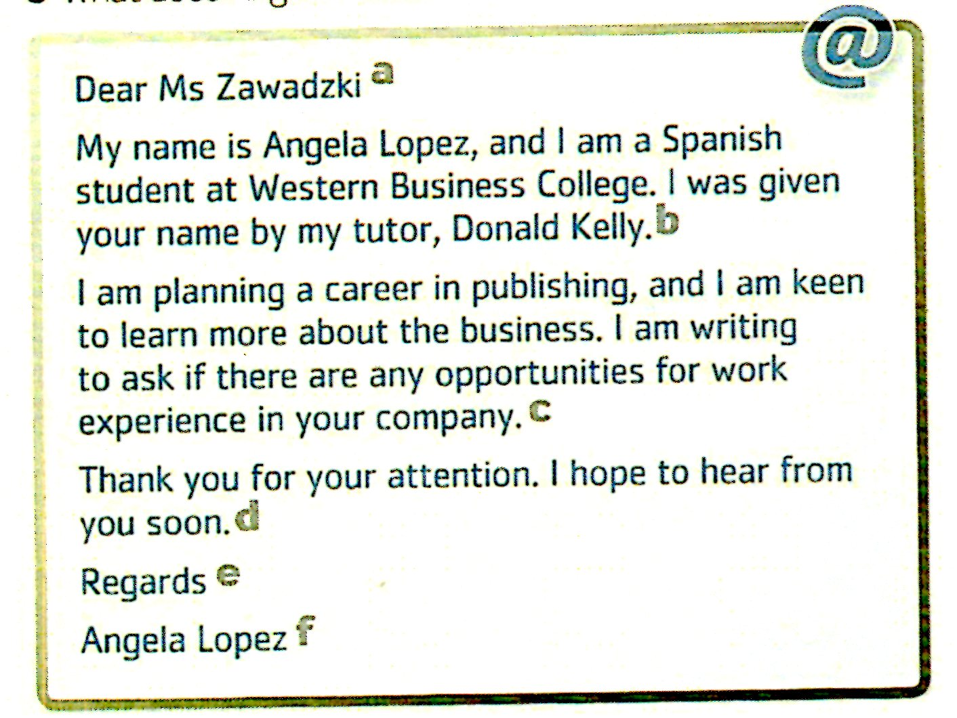

1- closing sentence ……

2- closing salutation ……

3- sender's name ……

4- opening salutation ……

5- reason for writing ……

6- introduction ……

**2/ Look through all the emails on this page and underline any useful expression in them. Then put the expressions into these categories.**

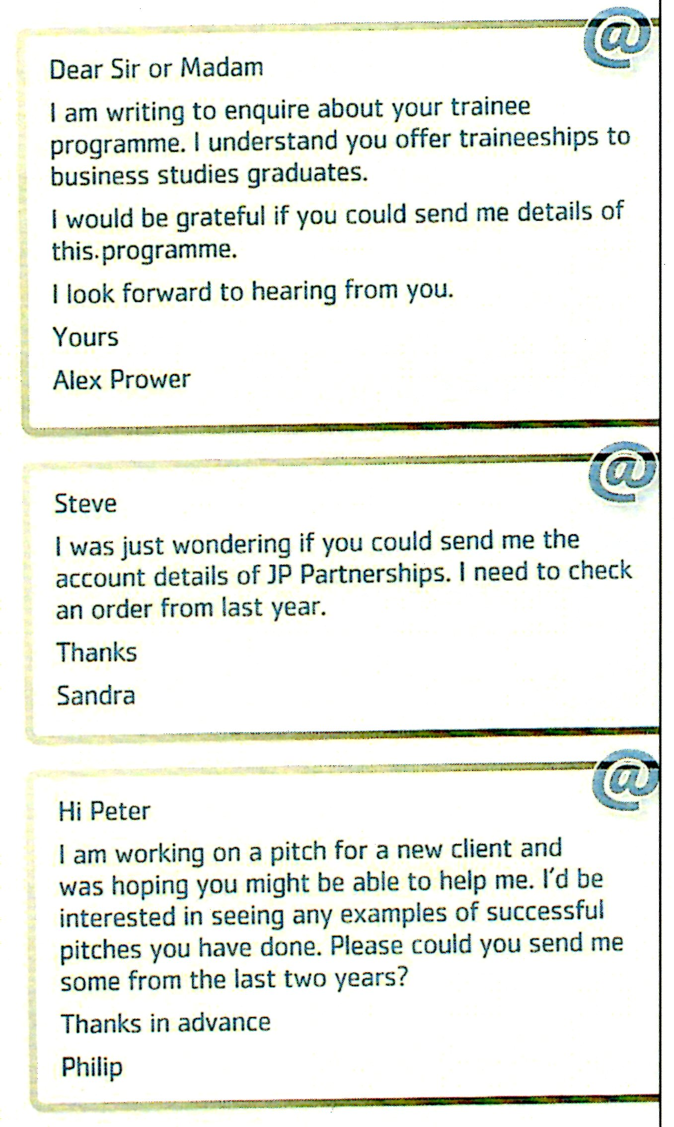

* Opening salutations

……………………………………………………

……………………………………………………

……………………………………………………

* Reason for writing

……………………………………………………

……………………………………………………

……………………………………………………

* Making a request

……………………………………………………

……………………………………………………

……………………………………………………

* Closing sentence

……………………………………………………

……………………………………………………

……………………………………………………

* Closing salutation

……………………………………………………

……………………………………………………

……………………………………………………

**Useful expressions.**

1- Find the equivalents in the list on the left.

1. Aussitôt que possible.
2. Restons en contact.
3. Merci d’avoir répondu si vite.
4. J’ai hâte d’avoir de vos nouvelles.
5. Cordialement / Salutations.
6. Videz la corbeille.
7. Relisez votre courriel.
8. Ce fichier est trop lourd.
9. Mes sentiments les meilleurs.
10. Les messages indésirables.
11. Tu as oublié le fichier joint.
12. Amitiés.
13. Best regards, / Yours sincerely, / Love,
14. Please keep in touch.
15. Thank you for replying so fast.
16. Could you please reply asap?
17. Looking forward to hearing from you.
18. FYI (For Your Information)
19. Proofread your e-mail before sending it.
20. You forgot the attachment.
21. This file is too heavy.
22. The emails you receive are in the inbox.
23. Junk mail is very annoying.
24. Delete the trash from time to time.

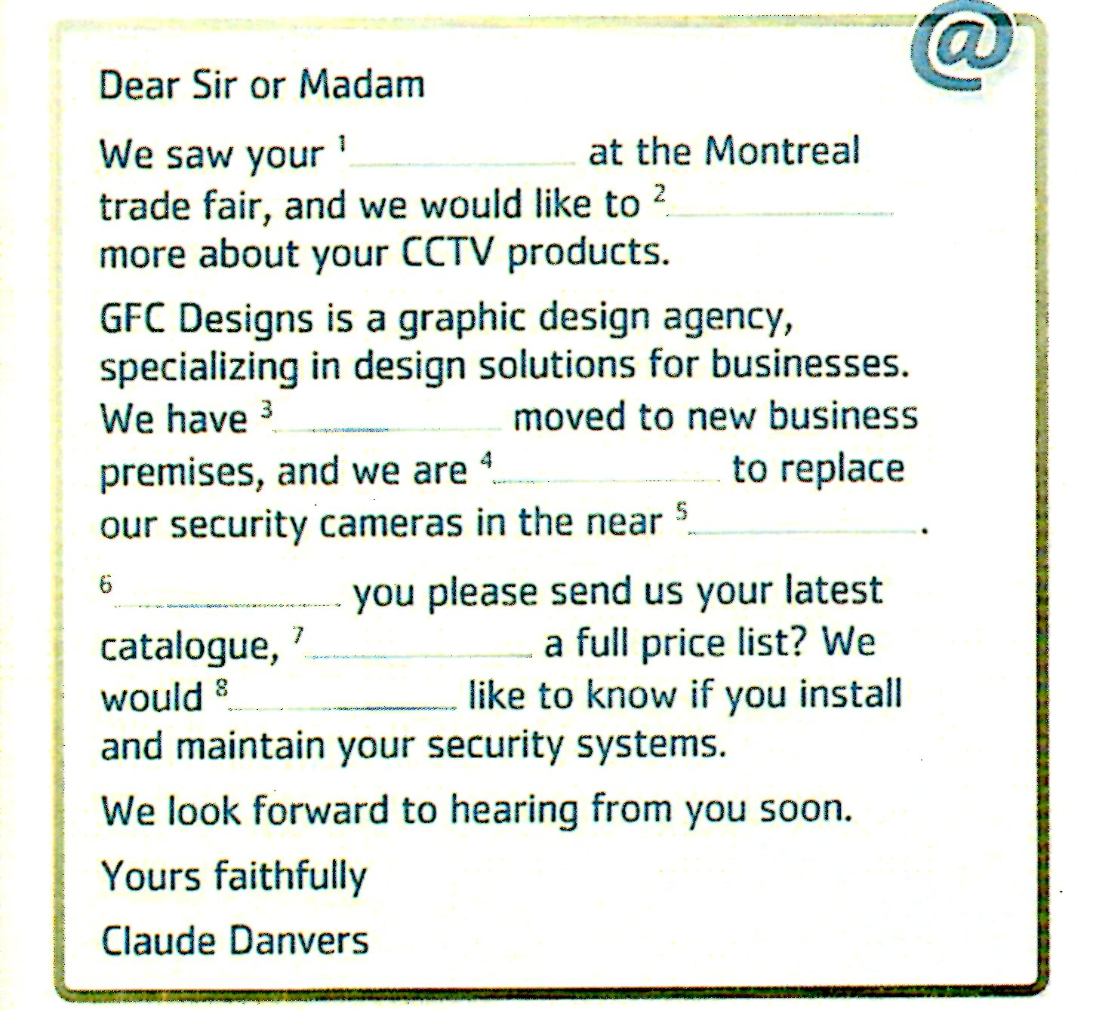

**2- Read and complete the email with these words.**

*could – recently – also – planning – future – know*

*Satnd - including*

**3- When you write an email you should organise**

**your ideas clearly. Number these items in the order**

**you find them in exercise 2.**

a. Request to reply .....

b. Your inquiry .....

c. Polite ending .....

d. Description of your company .....

e. How you know about the supplier .....

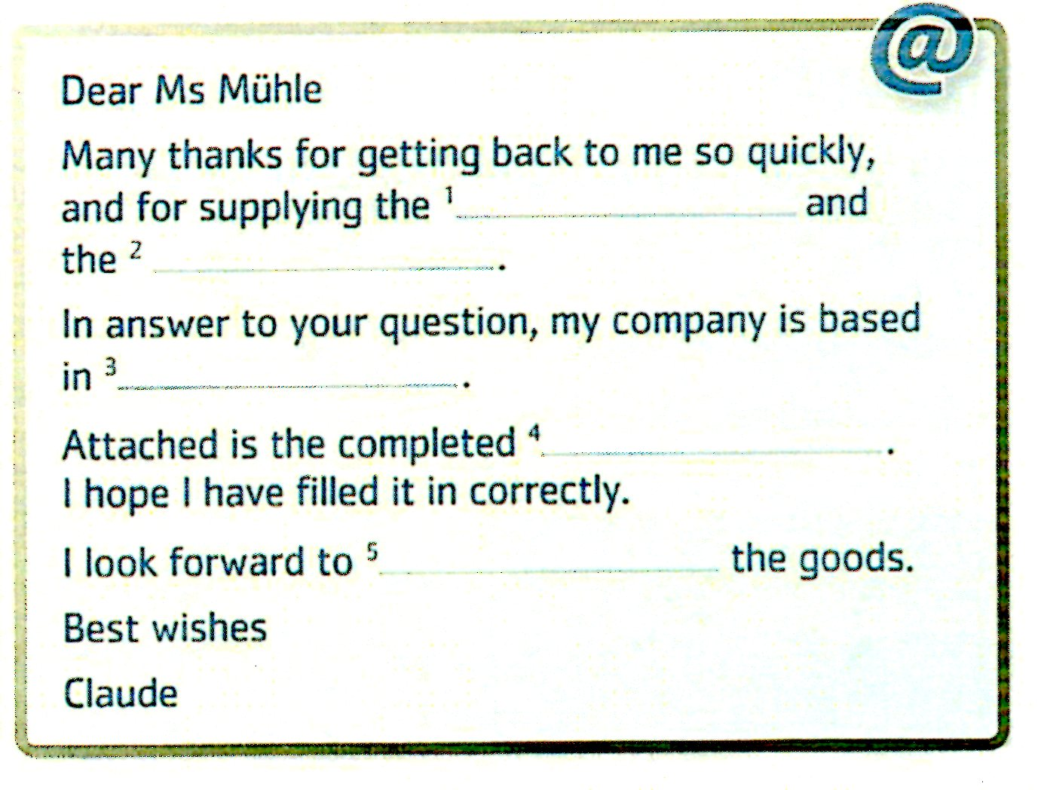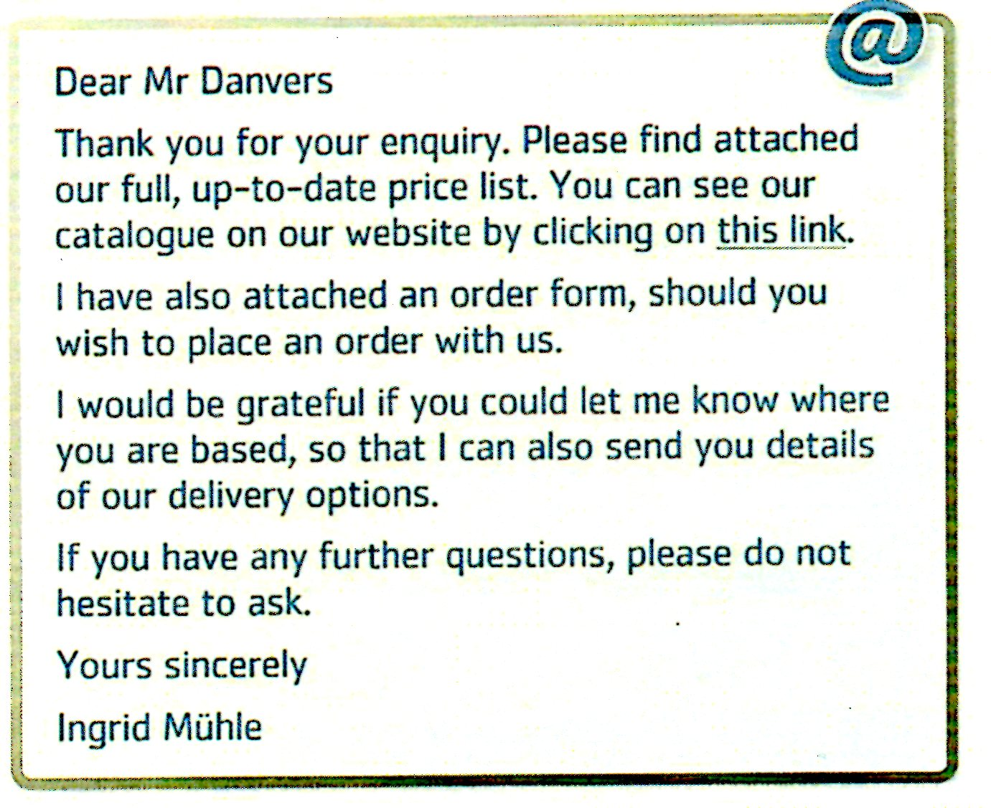**4- Read the two emails, complete the response with appropriate words.**

**5- Find phrases in the emails that come under these categories.**

* Acknowledging someone's email.
* Including separate files in the email.
* Polite ending

**6 – Pair work**(Each person writes an e-mail, then swap your e-mails and reply to your partner).

*You intend to enrol in a British university for summer courses next July. Write an email to request information about the courses, the campus, the facilities, the accommodation.*